# Release Information

|  |  |
| --- | --- |
| *Release* | *3* |
| *Leader* | *Xinyi Lyu* |
| *SVN Revision Number* | *67880* |

Customers can now purchase cars, and the cars will no longer show up in the search. The search page now allows you to rent a car in the future if it is currently rented, and cars now have pictures associated with them. Customers can report issues with vehicles.

# Progress Summary

|  |  |  |  |
| --- | --- | --- | --- |
| **Stories and spike solutions planned for this release** | | | |
| **Story, Spike** | **Description** | **% Impl.** | **Notes, plan for completion** |
| *S.SO.03* | *Admins can apply fees to a customer account if they have caused some grievance.* | *80* | *The fees are applied, but they are not designated to a specific rental.* |
| *S.UI.06* | *Admins can report crashed cars so that the car is not in the database.* | *100* | *The car has an attribute for isDamaged, this attribute is used for the admin to view on the reports page. They can then modify the report if the vehicle has been repairs, or if the damage is negligible* |
| *S.UI.02* | *Customers can report a vehicle they are renting as needing repairs.* | *100* |  |
| *S.UI.07* | *Customers can purchase a vehicle, which will remove it from the database.* | *100* | *No longer removing from the database, instead we are storing the purchase history in a new table.* |
| *S.IO.03* | *Admins can blacklist customers, so they will no longer be able to rent cars.* | *100* |  |
| *S.IO.01* | *Customers will be shown a confirmation page with the rental data with the final confirm button.* | *100* |  |
| *S.SO.05* | *As an admin, I need to be able to view a calendar because I want to see how many cars I am loaning in one day.* | *0* | *Was pushed back due to time constraints* |
| *Spike3* | *This spike is going to assist us in add vehicles pictures to the GUI* | *100* | *Found that storing pictures in access in nearly impossible, instead we are using static images saved in resources for each car type.* |

|  |  |  |
| --- | --- | --- |
| **Accomplishments by engineer** | | |
| **Team Member** | **Total Time (hrs)** | **Stories, Spikes implemented** |
| *Zackary* | *19* | *S.SO.03, S.UI.07* |
| *Sarah* | *20* | *S.IO.03, Spike3* |
| *Michael* | *18* | *Spike 3, S.UI.02* |
| *Xinyi* | *17* | *S.UI.06, S.IO.03, S.IO.01* |
| *Noah* | *17* | *S.SO.03, S.UI.07* |
| TEAM TOTAL | 81.***0*** |  |

|  |  |
| --- | --- |
| **Document updates** | |
| **Document** | **Changes** |
| *Story Book* | *We marked review customers' credit as removed, and have updated the implementation for all stories.* |
| *Class Diagram* | *Updated the class diagram to follow our new GUI logic, add commands in the class diagram.* |
| *Status Document* | *Updated since the beginning of 4/1* |

# Plan for Deployment

Deployment comes next, so we need to write tests for the system and make sure all documentation is up to date.

|  |  |  |  |
| --- | --- | --- | --- |
| **Assignments** | | | |
| **Team Member** | **Stories, Spikes implemented** | | **Tot. Hrs.** |
| *Zackary* | *Deployment* | *Tests, comments, class diagram* | *12* |
| *Sarah* | *Deployment* | *Tests, comments, Readme* | *12* |
| *Michael* | *Deployment* | *Tests, comments, storybook* | *12* |
| *Xinyi* | *Deployment* | *Tests, comments, clean files* | *12* |
| *Noah* | *Deployment* | *Tests, comments, test coverage doc* | *12* |
|  |  | **Total** | 60.**0** |

# Issues

|  |  |  |  |  |
| --- | --- | --- | --- | --- |
| **Issue Number** | **Discovery**  **Date** | **Resolution**  **Date (Est.–Act.)** | **Responsible Person** | **Description (Prob / Resolution)** |
| 01 | 4/18 | 4/24 | Noah | The credit score story was not seen as something within our scope. We needed to generate fake scores which hindered a user form renting a car. We decided to remove the story all together. |
| 02 | 4/9 | 4/25 | Mike & Zack | The filtering system had not been filtering out rental days for cars, and the solution was an extremely slow method that slowed down the system itself. We spent many hours trying to speed up the process. |
| 03 | 4/18 | 4/25 | Zack | For our original design we wished to have the vehicle removed from the vehicle list in the database once bought, but the relationship between a rental and a vehicle means we need to remove the rental as well as the car. So we remove all its associated rentals when removing a car. |
|  |  |  |  |  |

# Screen Shots

Customer reports an issue with the rental. The system will automatically fill in the rental information. The customer selects the date and makes a comment. They can submit it when they are ready.

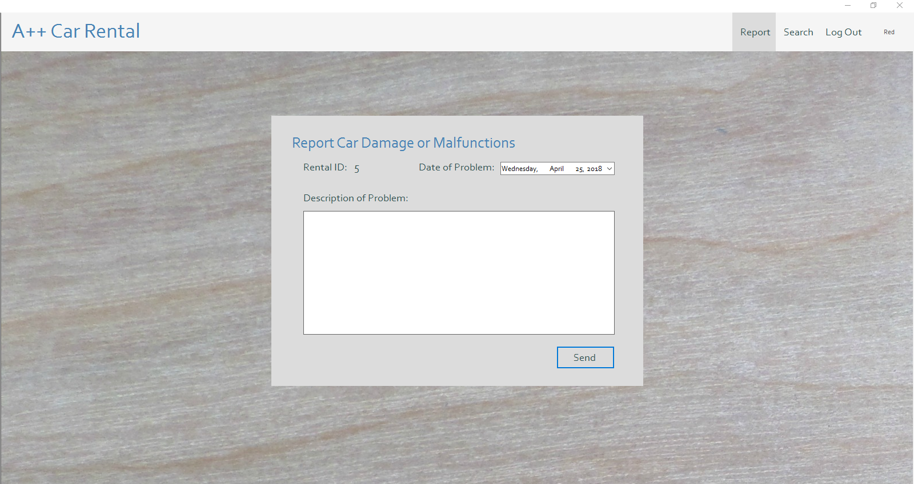

The admin can view all the reports sent by customers. The admin can select the report they want from the list and view the comment on the right.

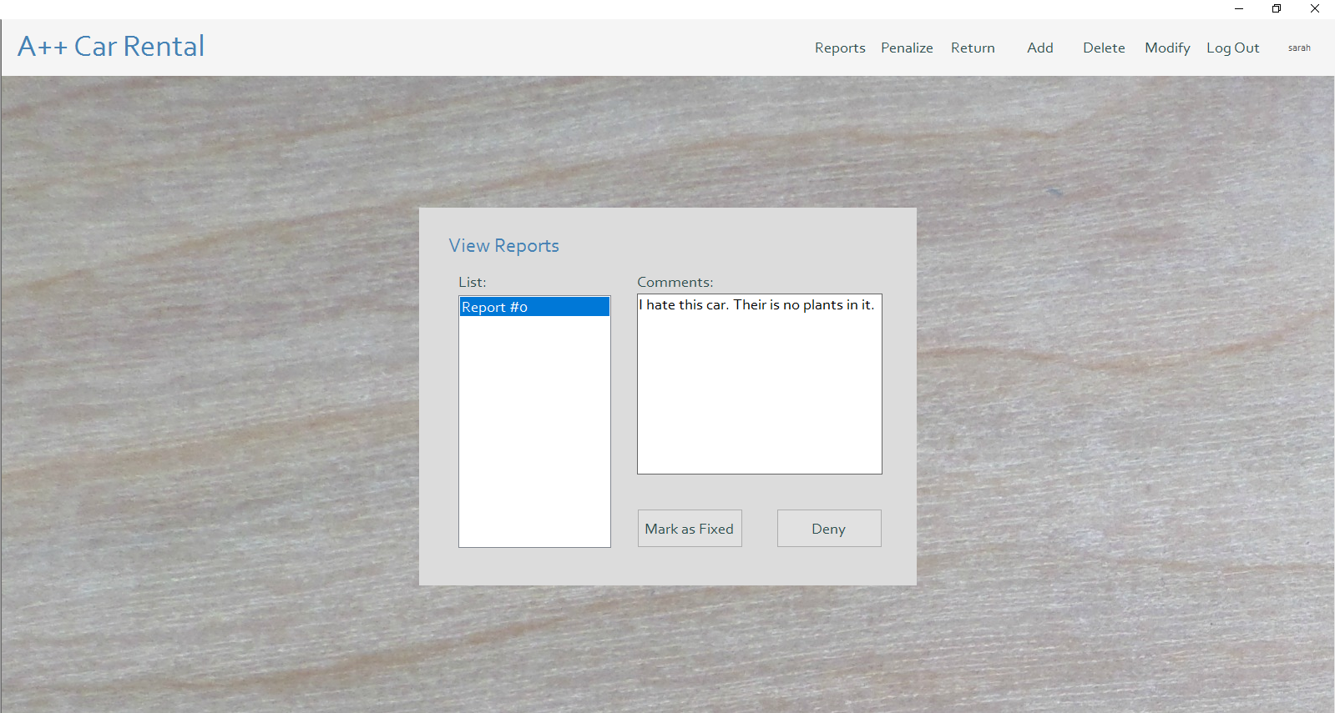

Customer reviews a rental before they make a purchase. They can also will add all the additional information the system needs.

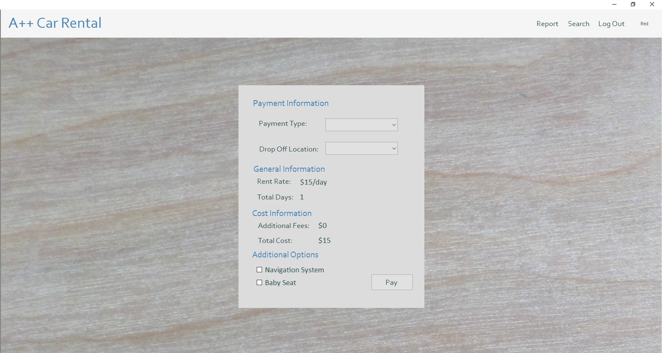

Customer wants to buy a vehicle. They can select buy if they are happy with the purchase.

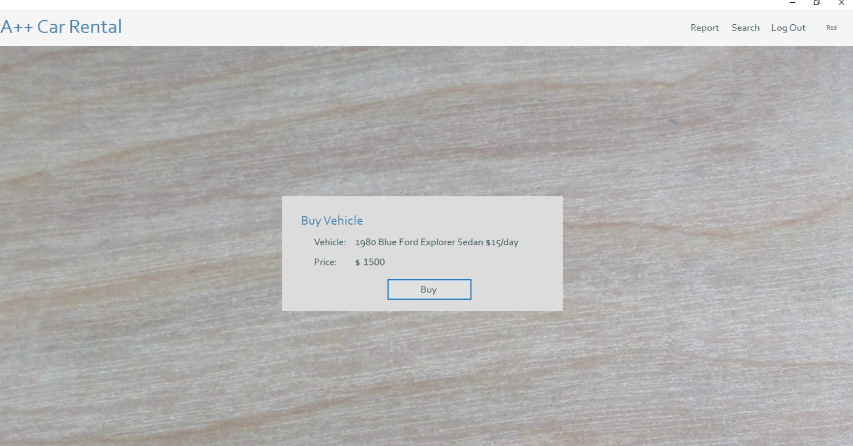

The admin wants to certain customer "James Bane" to have fees added to the rental. The admin selects the user they want, they add the money to the textbox on the side, and selects apply.

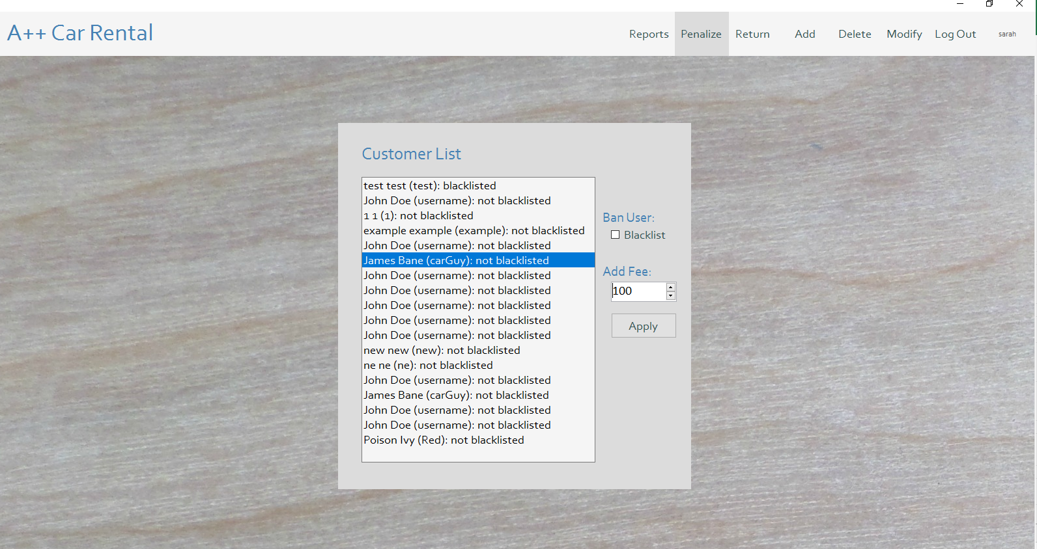

Admin wants to blacklist the customer "John Doe". The admin selects a user the want to blacklist and checks the Blacklist box on the side to ban them. The admin can also un-ban the user.

